**Mini Project Report on**



**AI POWERED METAVERSE VIRTUAL ASSISTANT (J.A.R.V.I.S.)**



**Submitted in partial fulfilment of the requirement for the award of the degree of**

**BACHELOR OF TECHNOLOGY**

**IN**

**COMPUTER SCIENCE & ENGINEERING**

**Submitted by:**

**NIMISH VYAS 2021595**

***Under the Mentorship of***

**MR. YOGESH LAOUMI**



**Department of Computer Science and Engineering**

**Graphic Era (Deemed to be University)**

**Dehradun, Uttarakhand**

**January-2025**



**CANDIDATE’S DECLARATION**

I hereby certify that the work which is being presented in the project report entitled **“JARVIS”** in partial fulfillment of the requirements for the award of the Degree of Bachelor of Technology in Computer Science and Engineeringof the Graphic Era (Deemed to be University), Dehradun shall be carried out by the under the mentorship of **MR. YOGESH LAHOUMI ,**Department of Computer Science and Engineering, Graphic Era (Deemed to be University), Dehradun.

NIMISH VYAS 2021595

**Table of Contents**

|  |  |  |
| --- | --- | --- |
| **Chapter No.** | **Description** | **Page No.** |
| Chapter 1 | Introduction 1-2 |  |
| Chapter 2 | Literature Survey 3-6 |  |
| Chapter 3 | Methodology 7-8 |  |
| Chapter 4 | Result and Discussion 9-10 |  |
| Chapter 5 | Conclusion and Future Work | **11-12** |
|  | References |  |

**Chapter 1**

**Introduction**

Artificial Intelligence when used with machines, it shows us the capability of thinking like humans. In this, a computer system is designed in such a way that typically requires interaction from human. As we know Python is an emerging language so it becomes easy to write a script for Voice Assistant in Python. The instructions for the assistant can be handled as per the requirement of user. Speech recognition is the Alexa, Siri, etc. In Python there is an API called Speech Recognition which allows us to convert speech into text. It was an interesting task to make my own assistant. It became easier to send emails without typing any word, Searching on Google without opening the browser, and performing many other daily tasks like playing music, opening your favorite IDE with the help of a single voice command. In the current scenario, advancement in technologies are such that they can perform any task with same effectiveness or can say more effectively than us. By making this project, I realized that the concept of AI in every field is decreasing human effort and saving time. As the voice assistant is using Artificial Intelligence hence the result that it is providing are highly accurate and efficient. The assistant can help to reduce human effort and consumes time while performing any task, they removed the concept of typing completely and behave as another individual to whom we are talking and asking to perform task. The assistant is no less than a human assistant but we can say that this is more effective and efficient to perform any task. The libraries and packages used to make this assistant focuses on the time complexities and reduces time. The functionalities include , It can send emails, It can read PDF, It can send text on WhatsApp, It can open command prompt, your favorite IDE, notepad etc., It can play music, It can do Wikipedia searches for you, It can open websites like Google, YouTube, etc., in a web browser, It can give weather forecast, It can give desktop reminders of your choice. It can have some basic conversation. Tools and technologies used are PyCharm IDE for making this project, and I created all py files in PyCharm. Along with this I used following modules and libraries in my project. pyttsx3, SpeechRecognition, Datetime, Wikipedia, Smtplib, pywhatkit, pyjokes, pyPDF2, pyautogui, pyQt etc. I have created a live GUI for interacting with the JARVIS as it gives a design and interesting look while having the conversation.

**Chapter 2**

**Literature Survey**

PRESENT SYSTEM

We are familiar with many existing voice assistants like Alexa, Siri, Google Assistant, Cortana which uses concept of language processing, and voice recognition. They listens the command given by the user as per their requirements and performs that specific function in a very efficient and effective manner. As these voice assistants are using Artificial Intelligence hence the result that they are providing are highly accurate and efficient. These assistants can help to reduce human effort and consumes time while performing any task, they removed the concept of typing completely and behave as another individual to whom we are talking and asking to perform task. These assistants are no less than a human assistant but we can say that they are more effective and efficient to perform any task. The algorithm used to make these assistant focuses on the time complexities and reduces time. But for using these assistants one should have an account (like Google account for Google assistant, Microsoft account for Cortana) and can use it with internet connection only because these assistants are going to work with internet connectivity. They are integrated with many devices like, phones, laptops, and speakers etc. 1.2 PROPOSED SYSTEM It was an interesting task to make my own assistant. It became easier to send emails without typing any word, Searching on Google without opening the browser, and performing many other daily tasks like playing music, opening your favorite IDE with the help of a single voice command. Jarvis is different from other traditional voice assistants in terms that it is specific to desktop and user does not need to make account to use this, it does not require any internet connection while getting the instructions to perform any specific task. The IDE used in this project is PyCharm. All the python files were created in PyCharm and all the necessary packages were easily installable in this IDE. For this project following modules and libraries were used i.e. pyttsx3, SpeechRecognition, Datetime, Wikipedia, Smtplib, pywhatkit, pyjokes, pyPDF2, pyautogui, pyQt etc. I have created a live GUI for interacting with the JARVIS as it gives a design and interesting look while having the conversation. With the advancement JARVIS can perform any task with same effectiveness or can say more effectively than us. By making this project, I realized that the concept of AI in every field is decreasing human effort and saving time. Functionalities of this project include, It can send emails, It can read PDF, It can send text on WhatsApp, It can open command prompt, your favorite IDE, notepad etc., It can play music, It can do Wikipedia searches for you, It can open websites like Google, YouTube, etc., in a web browser, It can give weather forecast, It can give desktop reminders of your choice. It can have some basic conversation.

PROPOSED SYSTEM

It was an interesting task to make my own assistant. It became easier to send emails without typing any word, Searching on Google without opening the browser, and performing many other daily tasks like playing music, opening your favorite IDE with the help of a single voice command. Jarvis is different from other traditional voice assistants in terms that it is specific to desktop and user does not need to make account to use this, it does not require any internet connection while getting the instructions to perform any specific task. The IDE used in this project is PyCharm. All the python files were created in PyCharm and all the necessary packages were easily installable in this IDE. For this project following modules and libraries were used i.e. pyttsx3, SpeechRecognition, Datetime, Wikipedia, Smtplib, pywhatkit, pyjokes, pyPDF2, pyautogui, pyQt etc. I have created a live GUI for interacting with the JARVIS as it gives a design and interesting look while having the conversation. With the advancement JARVIS can perform any task with same effectiveness or can say more effectively than us. By making this project, I realized that the concept of AI in every field is decreasing human effort and saving time. Functionalities of this project include, It can send emails, It can read PDF, It can send text on WhatsApp, It can open command prompt, your favorite IDE, notepad etc., It can play music, It can do Wikipedia searches for you, It can open websites like Google, YouTube, etc., in a web browser, It can give weather forecast, It can give desktop reminders of your choice. It can have some basic conversation.

**Chapter 3**

**Methodology**

**WORKING ALGORITHM OJ JARVIS:**

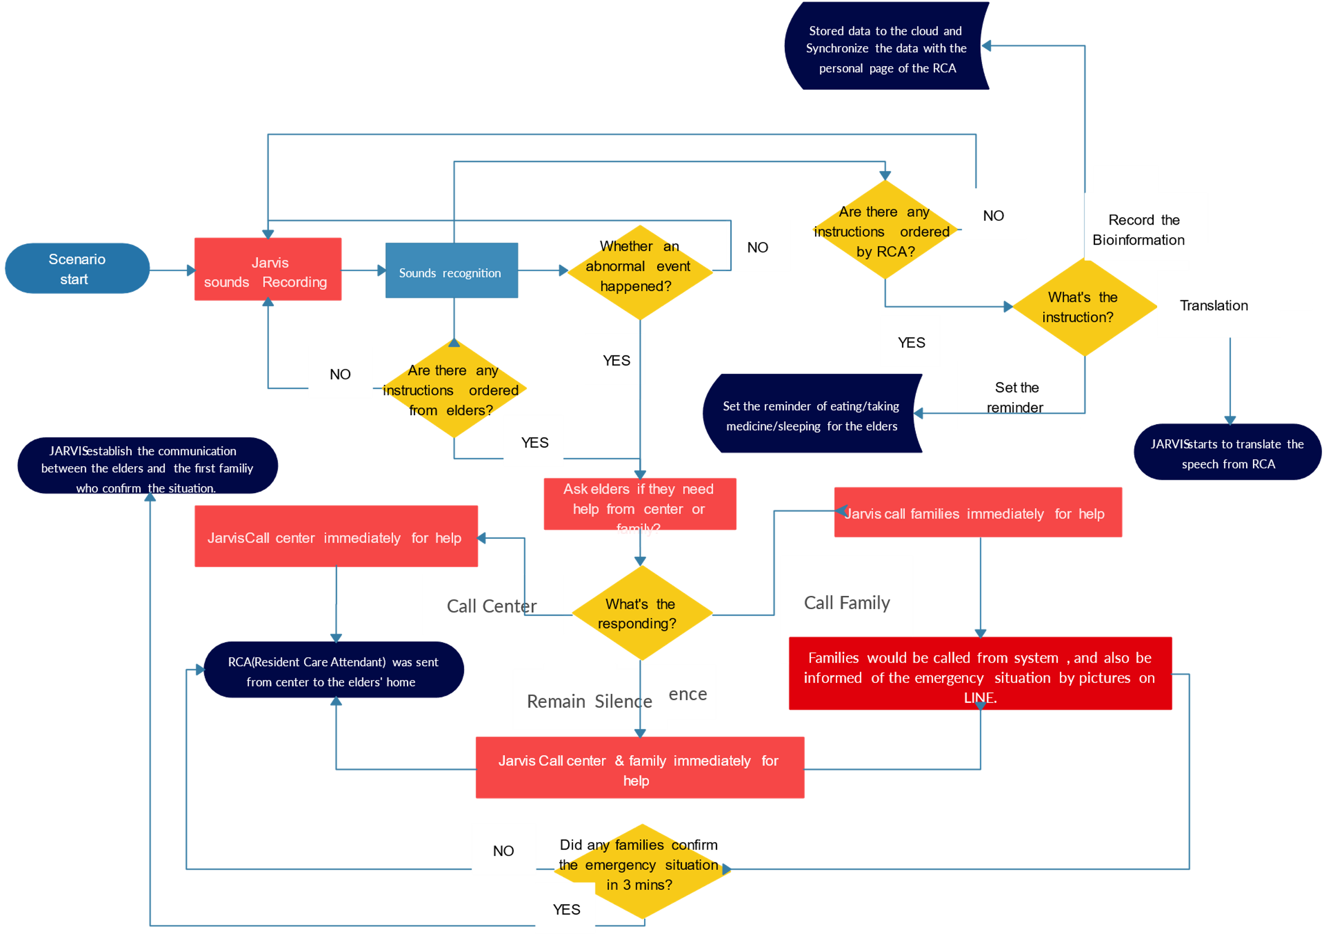

**USAGE AND THE FAST GROWING COMPANY OF MODERN AI:**

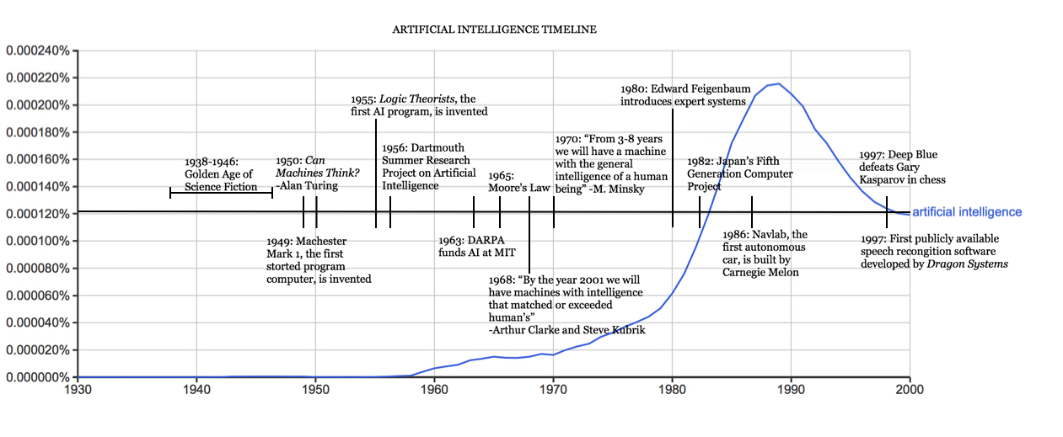

[This Photo](http://sitn.hms.harvard.edu/flash/2017/history-artificial-intelligence/) by Unknown Author is licensed under [CC BY-SA-NC](https://creativecommons.org/licenses/by-nc-sa/3.0/)

**Chapter 4**

**Result and Discussion**

.From installing of all the packages, importing, creating all the necessary functions, designing GUI in PyQT and connecting that live GUI with the backend, was all done by me individually. I, myself have done all the research before making this project, designed the requirement documents for the requirements and functionalities, wrote synopsis and all the documentation, code and made the project in such a way that it is deliverable at each stage.I have created the front end (.ui file) of the project using PyQt designer, the front end comprises of a live GUI and is connected with the .py file which contains all the classes and packages of the .ui file. The live GUI consists of moving GIFs which makes the front end attractive and user friendly. I have written the complete code in Python language and in PyCharm IDE from where it was very easy to install the packages and libraries, I have created the functions like takeCommand(), wishMe() and taskExecution() which has the following functionalities, like takeCommand() which is used to take the command as input through microphone of user and returns the output as string, wishMe() that greets the user according to the time like Good Morning, Good Afternoon and Good Evening and taskExecution()which contains all the necessary task execution definition like sendEmail(), pdf_reader(), news() and many conditions in if condition like “open Google”, “open notepad”, “search on Wikipedia” ,”play music” and “open command prompt” etc. While making this project I realized that with the advancement JARVIS can perform any task with same effectiveness or can say more effectively than us. By making this project, I realized that the concept of AI in every field is decreasing human effort and saving time. Functionalities of this project include, It can send emails, It can read PDF, It can send text on WhatsApp, It can open command prompt, your favorite IDE, notepad etc., It can play music, It can do Wikipedia searches for you, It can open websites like Google, YouTube, etc., in a web browser, It can give weather forecast, It can give desktop reminders of your choice. It can have some basic conversation. At last, I have updated my report and completed it by attaching all the necessary screen captures of inputs and outputs, mentioning the limitations and scope in future of this project.

**Chapter 5**

**Conclusion and Future Work**

JARVIS is a very helpful voice assistant without any doubt as it saves time of the user by conversational interactions, its effectiveness and efficiency. But while working on this project, there were some limitations encountered and also realized some scope of enhancement in the future which are mentioned below:

LIMITATIONS:

* Security is somewhere an issue,
* There is no voice command encryption in this project.
* Background voice can interfere,
* Misinterpretation because of accents and may cause inaccurate results,.
* JARVIS cannot be called externally anytime like other traditional assistants like Google Assistant can be called just by saying, “Ok Google!”

SCOPE FOR FUTURE WORK:

* Make JARVIS to learn more on its own and develop a new skill in it.
* JARVIS android app can also be developed.
* Make more Jarvis voice terminals.
* Voice commands can be encrypted to maintain security.

**References**

[1] <https://www.jetir.org/papers/JETIR2003165.pdfReearch> paper from goggle 2014 microtech paper

[2] https://www.emerald.com/insight/content/doi/10.1108/LHT-09-2021-0330/full/pdf?title=chatbots-and-virtual-assistants-a-bibliometric-analysis

[3] https://www.nvidia.com/en-in/ai-data-science/ai-workflows/intelligent-virtual-assistant/

[4][**https://github.com/topics/virtual-assistant**](https://github.com/topics/virtual-assistant)